­VoidStar Technical Design Document

*Insert possible Photoshop design here*

***‘Catchy Game Tagline’*** - you

|  |  |  |
| --- | --- | --- |
| **Table of Contents**  [1 Executive](https://n-xovwktmtjsnaxyc2mwes2xu7pohqedmdm6zjw5q-2lu-script.googleusercontent.com/userCodeAppPanel) Summary  Game Overview  Technical Summary  [2 Equipment](https://n-xovwktmtjsnaxyc2mwes2xu7pohqedmdm6zjw5q-2lu-script.googleusercontent.com/userCodeAppPanel)  Hardware  Software  [3 Evaluation](https://n-xovwktmtjsnaxyc2mwes2xu7pohqedmdm6zjw5q-2lu-script.googleusercontent.com/userCodeAppPanel)  Game Engine  Target Platform  [4 Scheduling](https://n-xovwktmtjsnaxyc2mwes2xu7pohqedmdm6zjw5q-2lu-script.googleusercontent.com/userCodeAppPanel)  Development Plan  Deadlines  [5 Work](https://n-xovwktmtjsnaxyc2mwes2xu7pohqedmdm6zjw5q-2lu-script.googleusercontent.com/userCodeAppPanel) Environment  Remote Collaboration  [6 File](https://n-xovwktmtjsnaxyc2mwes2xu7pohqedmdm6zjw5q-2lu-script.googleusercontent.com/userCodeAppPanel) Formats & Naming Convention  **\*\*Pending\*\***  [7 Levels](https://n-xovwktmtjsnaxyc2mwes2xu7pohqedmdm6zjw5q-2lu-script.googleusercontent.com/userCodeAppPanel)   |  | | --- | |  | | VoidStar Development Team Members    PRODUCERS  CLAYTON MATULICH  ELIE PUFFELIS  ERNESTO PARRA  YAO WANG    PRODJECT MANAGER  ERNESTO PARRA    PRODUCTION COORDINATOR  ERNSTO PARRA  GAME DESIGNERS  CLAYTON MATULICH  ELIE PUFFELIS  ERNESTO PARRA  YAO WANG  SYSTEMS COORDINATOR  YAO WANG  PROGRAMMERS  CLAYTON MATULICH  ELIE PUFFELIS  YAO WANG  TECHNICAL ARTISTS  ELIE PUFFELIS  AUDIO ENGINEERS  ELIE PUFFELIS  QUALITY ASSURANCE TESTERS  CLAYTON MATULICH  ELIE PUFFELIS  ERNESTO PARRA  YAO WANG |

|  |
| --- |
|  |

# **1 Executive Summary**

Game Overview

Void Star is a first-person, timed, survival shooter game where the Player is a star pilot (boy or girl) who is on a mission to defend their base from being destroyed. Now the Player must run through their base and get to the loading dock where the star fighters are located, select one of them and take it up to space to defend from the oncoming attack from above. The Player may acquire points from destroying enemy ships, the more that are destroyed in the given time frame the better.

Technical Summary

Void Star will be developed in about 3 weeks by 4 people using the Unity Gaming Engine. For the asset creation Google Poly was used in order to find the desired assets as well as other websites such as the Unity Asset Store. The game was developed as a student project for an Advanced 3D Game Design class and will not be used to accumulate any form of revenue and will not be published to any store for distribution.

The game will initially be deployed on Mac OS with plans for an iOS release down the line.

**Minimum Mac OS X requirements**:

PC – Mac

OS – Mac OS X 10.14.4

Graphics Card – Intel Iris Plus Graphics 640 1536 MB

**Minimum iOS Requirements**:

iPhone – Any phone after iPhone 7 should work properly running iOS 12.2

iPad – 6th Generation iPad running iOS 12.2 or higher

**2 Equipment**

Hardware

The four members of this development team used an all Mac setup which including of two 2018 13-inch MacBook Pro’s, one 2018 15-inch MacBook Pro, and one 2015 15-inch MacBook Pro. All MacBook’s are running the latest version of Mac OS X Mojave 10.14.4. Additional hardware choices included an iPhone XS Max running iOS 12.2 to begin testing deployment for the game in iOS.

|  |  |  |  |
| --- | --- | --- | --- |
| Product | Task | Quantity | Cost |
| MacBook Pro 13’ | Documentation  Programming  Game Creation  Game Testing | 2 | ~$3,600 |
| MacBook Pro 15’ | Programming  Game Creation  Game Testing  Photoshop | 2 | ~$6,000 |

**Total: $9,600**

Software

The software used in the creation of this game was mainly the Unity Engine implementing the C# language, Microsoft Word to write the documentation, Photoshop for some designs used in the documentation (**Possible)**, GitKraken and GitHub for version control, and Google Poly for finding the desired assets for the game. The use of software from each team member depended on their role and responsibility they played in the development of this game. Programmers being the ones who used Unity the most to actually create the game.

|  |  |  |  |
| --- | --- | --- | --- |
| Product | Task | Cost | Quantity |
| Unity 2019 | Game Creation and Development | Free | 4 |
| Microsoft Word Student Edition | Writing Documentation | Free | 1 |
| Photoshop | Designs | $25/year | 1 |
| Google Poly | Asset Finding | Free | 2 |
| GitKraken | Version Control | Free | 3 |
| GitHub | Version Control | Free | 1 |

**Total: $25**

**3 Evaluation**

Game Engine

The gaming engine utilized to created Void Star is the Unity Gaming Engine (Personal Edition). With Unity it is very easy to visualize and create a 3D game in this engine and the process of putting the game together and to build the game on several different platforms made the game creation process easier.

Target Platform

Void Star was initially created with the idea to make the game for the Mac OS platform on computer but there is work currently being done to bring this game to the mobile platform, specifically iOS. The Mac platform was easy for us to deploy on since this game was created and tested on said platform, but we understand that this is not the most popular platform. Being able to deploy the game on a mobile platform could bring the game to more people if it were ever released to an audience. Bringing the game to two different markets.

**4 Scheduling**

Development Plan

|  |  |  |  |  |
| --- | --- | --- | --- | --- |
| Product | Week 1 | Week 2 | Week 3 | Week 4 |
| Brainstorm Meetings | Game Concept,  Role Assignment, Platform Deployment | Idea for implementing AI and PCG in game | Idea for iOS deployment |  |
| Assets, Art & Design | Style for game selected | Use of old assets | Search for new assets |  |
| Game Layout | Physical drawn out game design | Began the design of levels | Further design of levels | Ideas for layout of iOS layout |
| Scripting |  | Character select, character movement, menu scene, first person shooter and views | UI Functionality, game timer, score keeper, improvement of character movement, terrain adjustments | Discussion of Unity Cloud Build for extra credit |
| Audio & Images | Folders created for audio and image housing | Skyboxes created and audio added |  |  |
| Documentation |  | Began rough draft GDD & TDD, readme update | Rough Draft of TDD & GDD finished, Issue 1 listed, wiki page for works cited created, readme pushed |  |

Deadlines

**April 30th** – MVP Due with GDD and TDD rough drafts

**May 7th or 9th** – Final game presentation due with final drafts of GDD and TDD

**5 Work Environment**

Remote Collaboration

The team is comprised of four members, three undergraduate and one graduate computer science students from San Diego State University. Four students with busy induvial schedules had us consider the best possible option to be able to work together being physically apart so we used version control software such as GitKraken and GitHub in order to push and pull changes to the project and creating branches for members to work on their own work.

**6 Levels**

Level 1

Void Star begins with the player waking up after an assault has been launched on their planet of Yavin. The player will spawn at the same point for every iteration. The initial level is a large terrain with a temple in the middle where the players first objective lies. Laser blast rain down from the sky and walkers stand in the players way of making it to their objective.



Level 2

Once the player makes it to their objective they are transported to space where the main purpose of the game is played out. The first-person shooter view will put the player in a turret like position where the player can look around shoot and destroy the enemy boids.

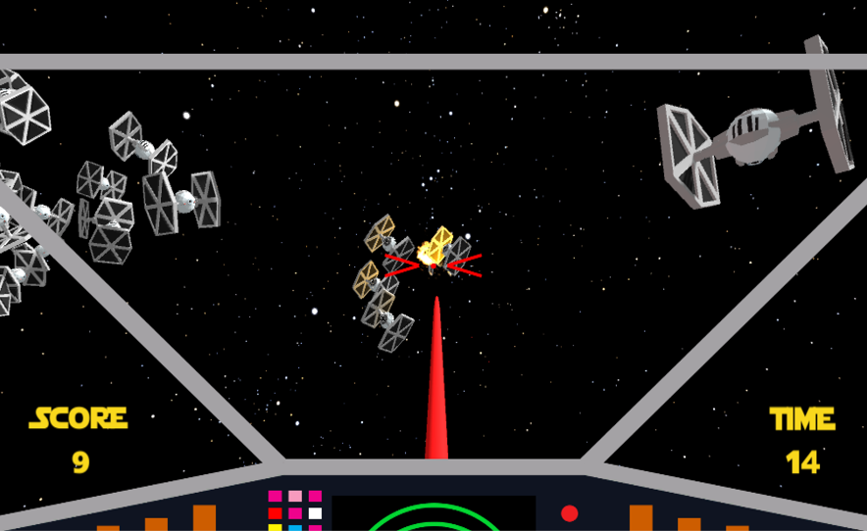

Asset List

|  |  |
| --- | --- |
| Player | Game Camera |
| Enemies | Tie Fighters |
| Player Ships | X-Wing  Tie Fighters  Tie Silencers |
| Terrain Walkers | ATST’s |
| Environment | Yavin Temple  Terrain created in Unity |